
Report
Name:
Reg no: Sp23-BSE-
Subject: Visual Programming
Submitted to : Sir Mubashir
University: COMSATS University Islamabad,

Vehari Campus

Coffee Management System

1. Introduction
This project is a Coffee Management System developed using Laravel. The system is designed to manage coffee products, ingredients, recipes, customers, and orders efficiently. It provides a centralized Admin Dashboard with statistics, charts, and full control over the system.

2. Objectives of the Project
- To manage coffee products and categories
- To handle customers and their orders
- To track total sales and top-selling products
- To provide an admin-controlled dashboard for monitoring
- To visualize data using charts

3. System Users & Roles

3.1 Admin
- Full control over the system
- Manage products, categories, ingredients, recipes
- View total customers, products, and orders
- View analytics (Top Selling Products, Orders)

3.2 Customers
- View coffee products
- Place orders
- Stored in separate customers table

4. System Architecture

4.1 Technology Stack
- Backend: Laravel (PHP Framework)
- Frontend: Blade Templates, HTML, CSS, Bootstrap
- Database: MySQL
- Charts: Bar Charts (Top Selling Products)

5. Database Design (Migrations)
The following tables are used in the system:
- users – Admin authentication
- customers – Customer information
- categories – Product categories
- ingredients – Coffee ingredients
- products – Coffee products
- recipes – Coffee recipes
- recipe_items – Ingredients used in recipes
- orders – Customer orders
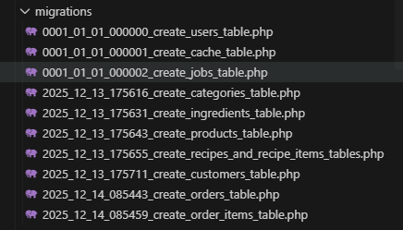
- order_items – Products in each order

6. Models Used
- User
- Customer
- Category
- Ingredient
- Product
- Recipe
- RecipeItem
- Order
- OrderItem
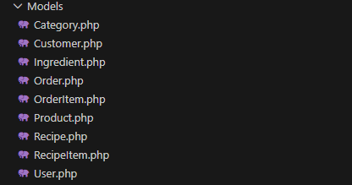
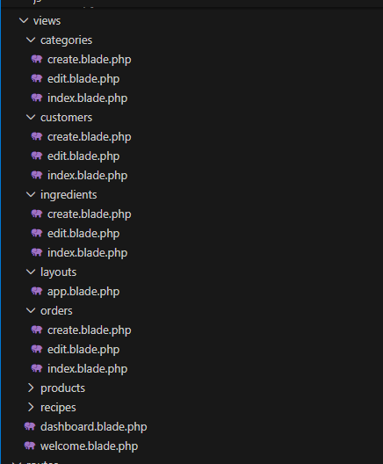.

7. Admin Dashboard
The Admin Dashboard provides:
- Total Customers count
- Total Products count
- Total Orders count
- Top Selling Products (Bar Chart)
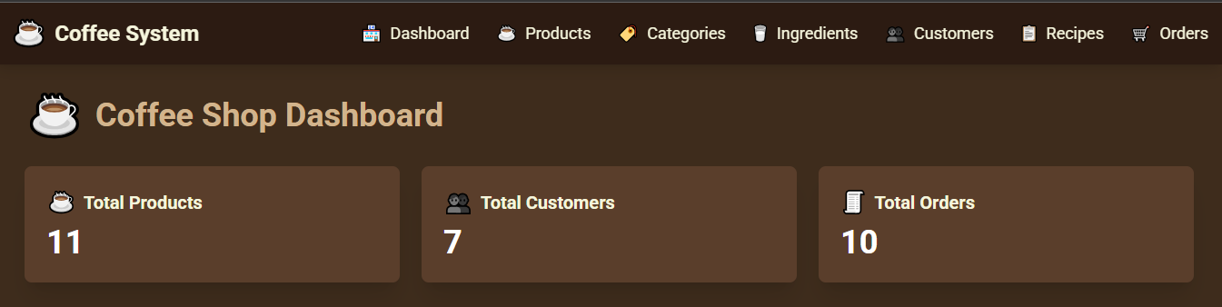
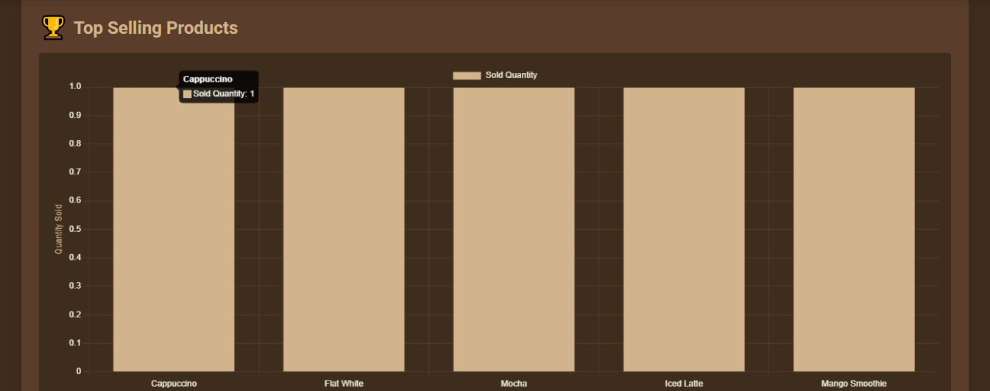

8. Product & Image Management
- Products include images stored in a dedicated images folder
- Each product has name, price, category, and image
- Images are displayed on product listing pages
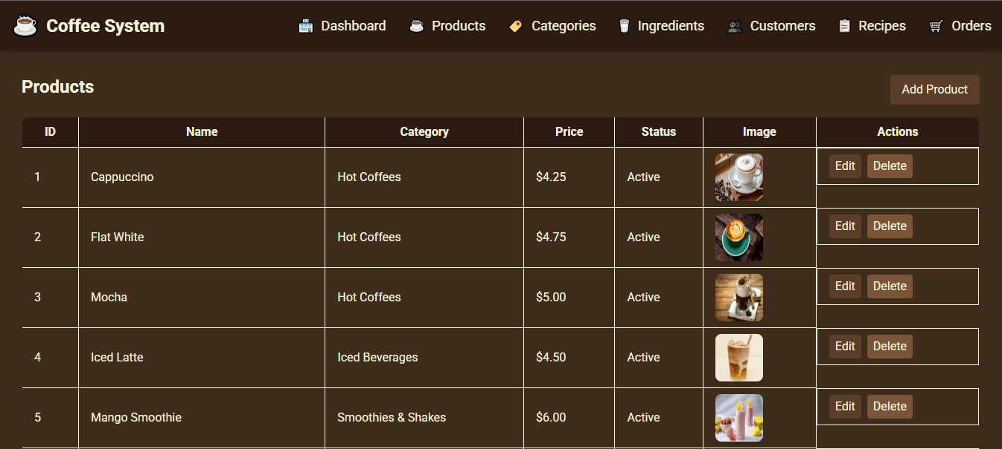

9. Ingredients

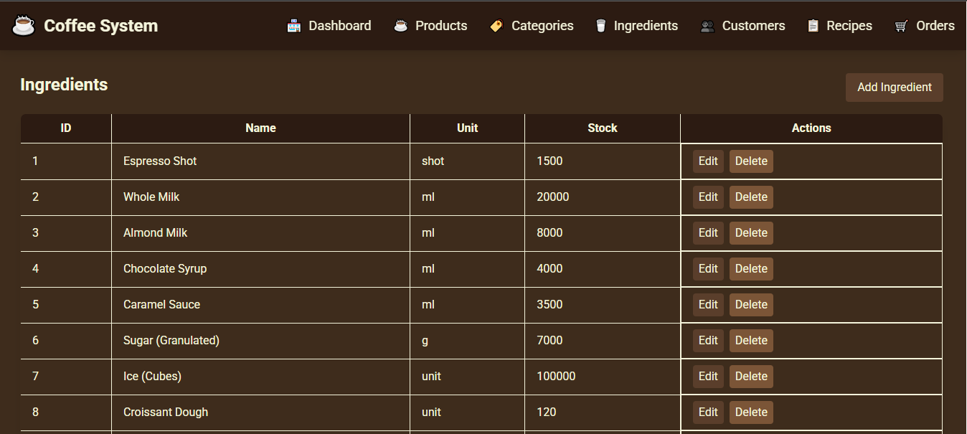

`

10. Categories

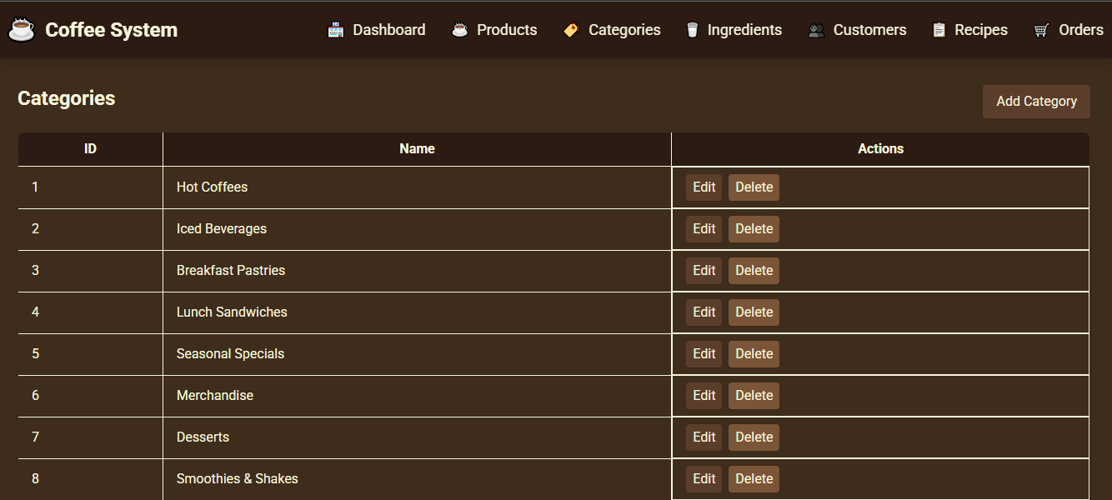

11.Customers

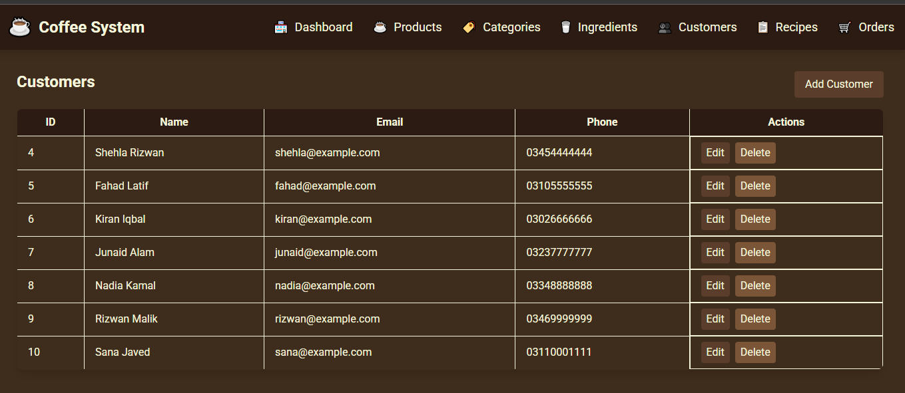

12.Recipes

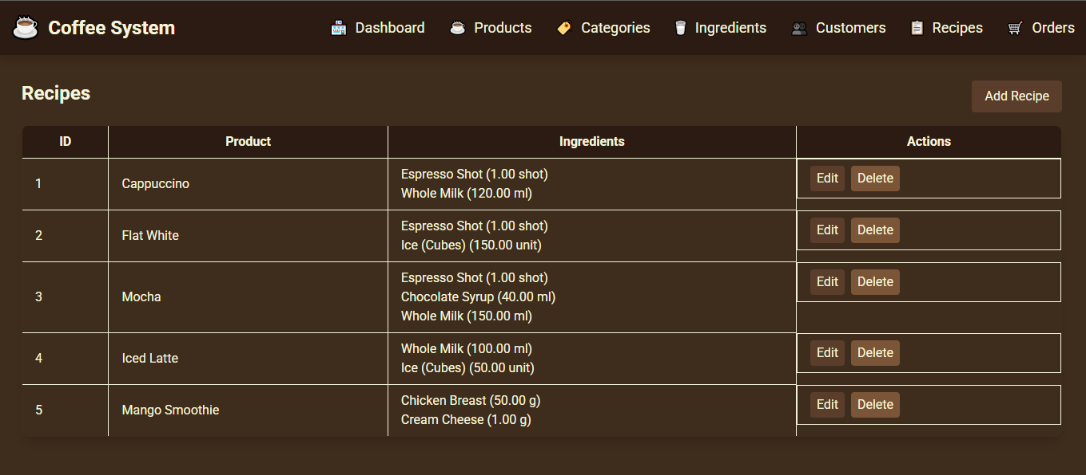

13. Orders Management
- Admin can view all orders
- Each order contains multiple order items
- Orders are linked with customers

14. Charts & Analytics
- Bar charts show Top Selling Products
- Helps admin analyze business performance

15. Routing & Controllers
- All routes are defined in web.php
- Controllers handle CRUD operations
- Admin routes are protected

16. Conclusion
The Coffee Management System successfully provides an admin-controlled platform to manage coffee products, customers, and orders. The dashboard, charts, and organized database structure make the system efficient, secure, and user-friendly.

17. Future Enhancements
- Customer login & order history
- Online payment integration
- Sales reports export (PDF/Excel)
- Role-based access (Admin / Staff)

